Laravel Helpline:

https://laravel.com/

**Composer Install**

**1.click composer steup.exe**

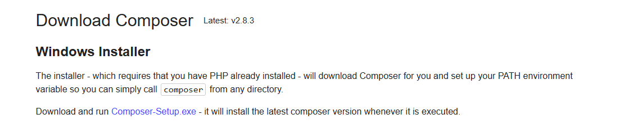

**2.Intall composer**

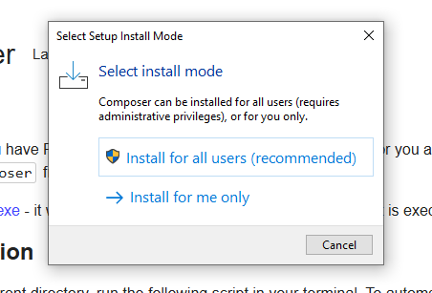

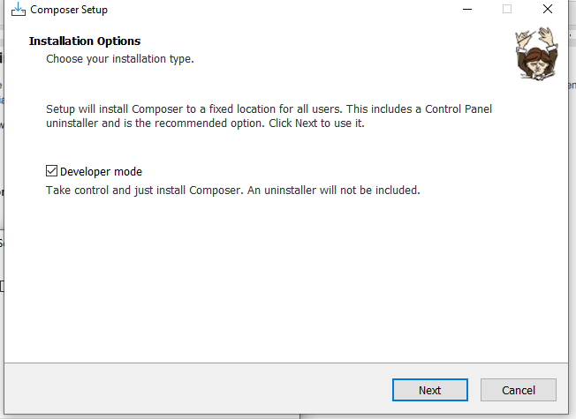

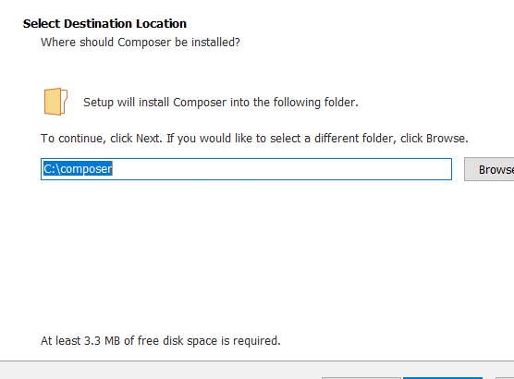

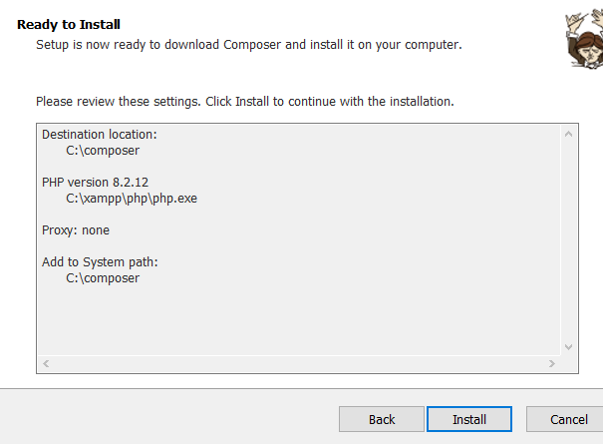

After installed

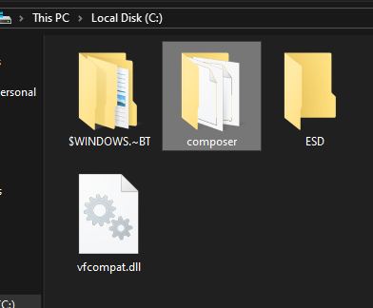

**3.See version of composer**

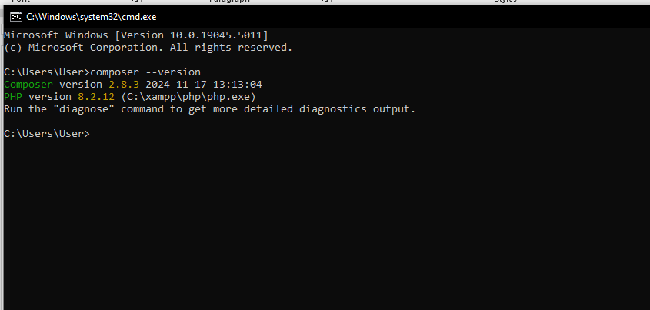

**Laravel installation**

**1.**

**(Global installation)[only first time][no need after installation]**

composer global require laravel/installer

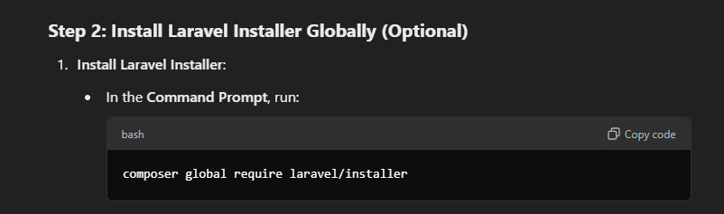

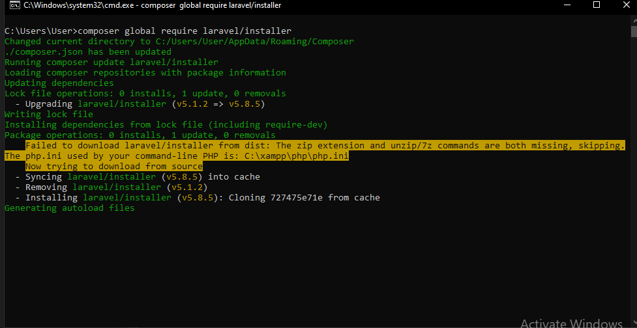

**2.**

**Create project(নির্দিষ্ট ফোল্ডারে গিয়ে প্রজেক্ট তৈরি করব।)**

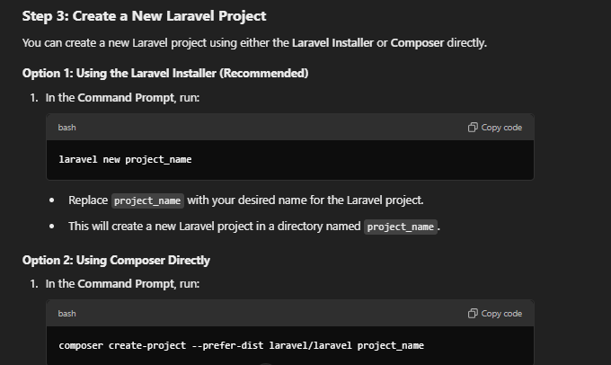

composer create-project --prefer-dist laravel/laravel FirstProject or ProjectName

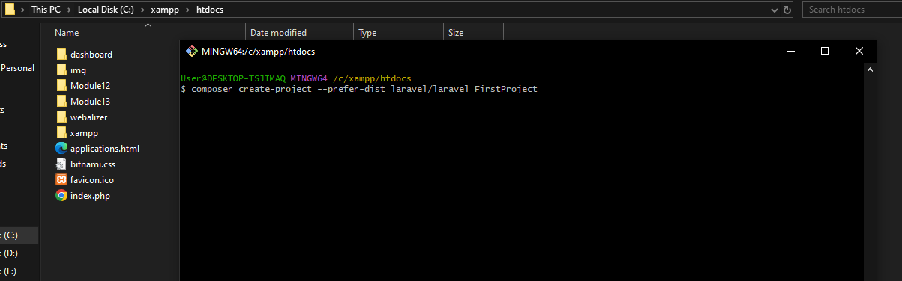

Project Created

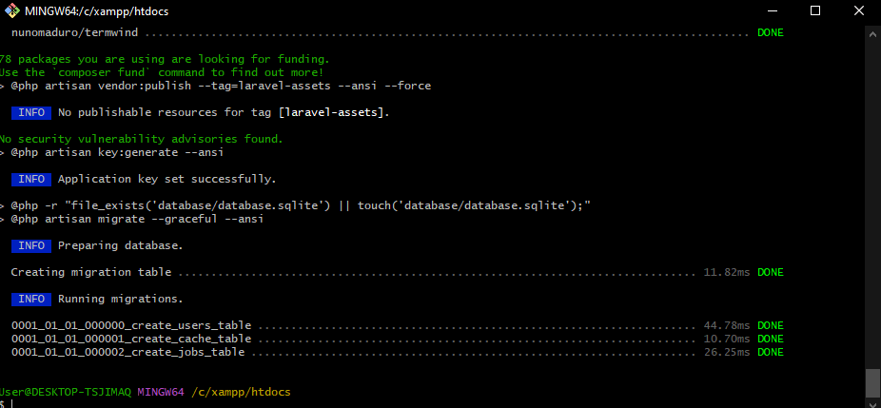

Folder open using VS Studio

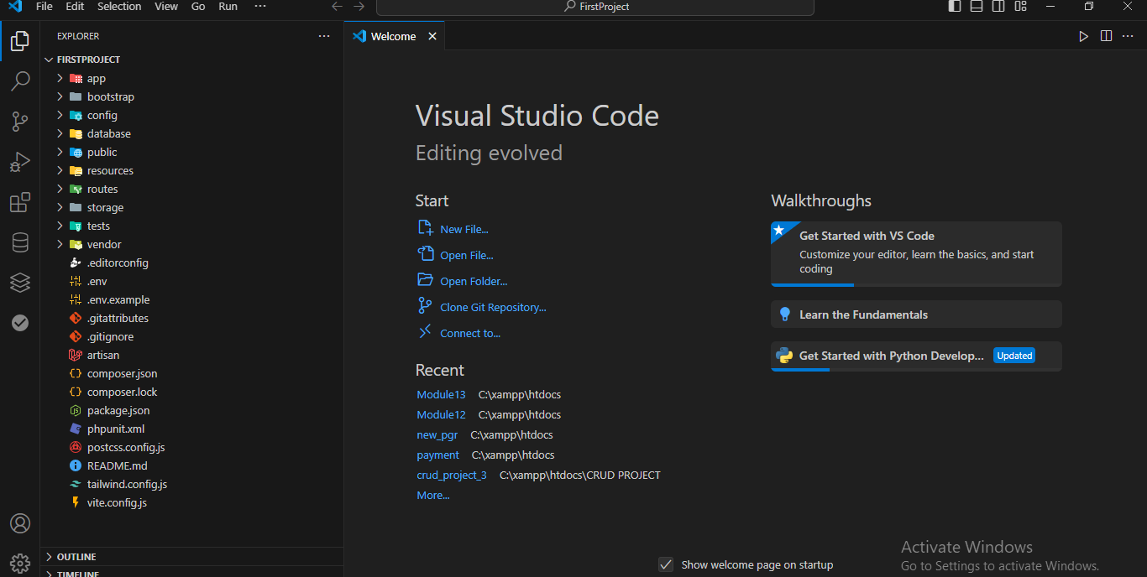

3.artisan serve

**php artisan serve**

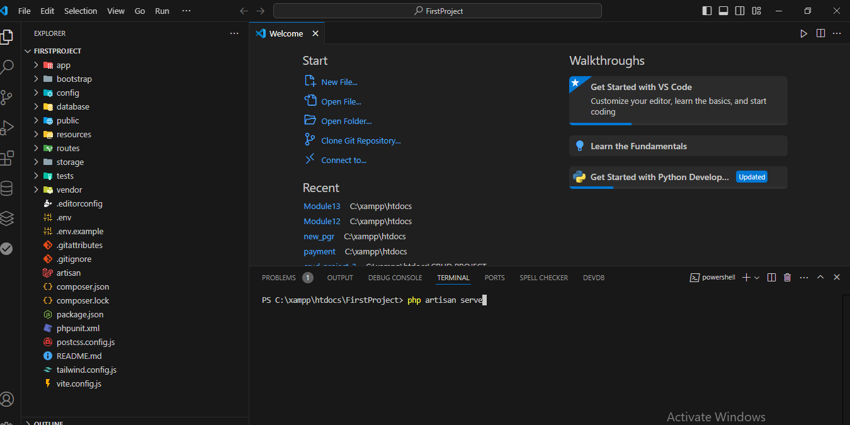

Project will open

